CT70A3100 Service Design

Tutorial Assignment – W6 Tutorial 6

Group
Hyechan Shin
Robert Gabrielsson
Amirhossein Mirsoleimani

The Silent Game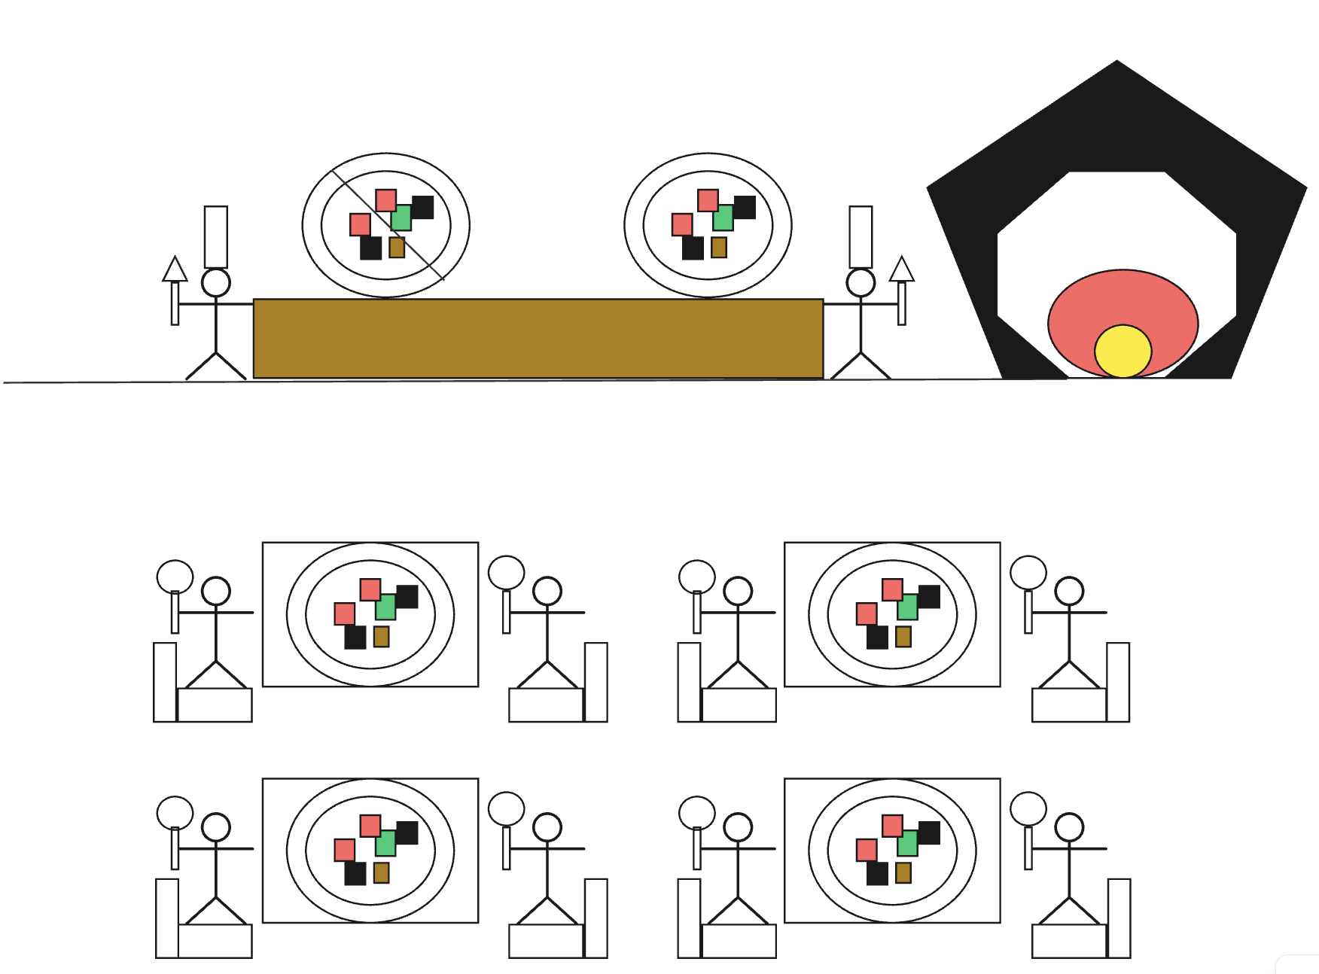
I acted as the Lead Designer for this exercise. I worked alongside Robert Gabrielsson, who took on the role of Assistant Designer, and Amirhossein Mirsoleimani, who acted as our Observer.

My initial strategy was to build a pizza restaurant layout, complete with a back-of-house oven, two chefs, and front-of-house dining tables. However, due to the need to be silent and not write anything on paper to indicate my intentions, I had to convey everything only through positioning of our material for Amirhossein to understand that we are building a kitchen.

Key takeaways
The key takeaway from this exercise is how heavily communication is required in collaborative work. While visual communication is important for teamwork, verbal communication is equally important. In our debriefing session, our Observer stated that the whole idea became clear to them only after they saw that the abstract images resembled chefs and plates full of food. I have realized that when an Assistant Designer lacks a clear idea of the destination, there is a high risk that abstract designs may lead to miscommunication. The lesson I learned is that to lead the design process collaboratively without giving instructions, the designer must create clear visual reference points.

AI Clarification
ChatGPT was used for grammar check.

